

IONITY GLOBAL
(Pty) Ltd

SHOUT-IT-NOW
Implementation Roadmap — IR
From Audit to Execution — Pathways, DOME Backbone & SOP
Five Pathways · DOME-Network · SOP · IA·MCP · AI Governance · ERP · AI Data Platform

ION-IR-2026-001 | Version 4.0 | 22 July 2026
CONFIDENTIAL

www.ionity.today | ai@ionity.today

Index – Table of Contents
This document is structured into nineteen main sections plus appendices. Use this index to navigate directly to any section.

Section | Topic | Page
1 | Executive Summary | 3
2 | Purpose, Scope & SOW Alignment — 10 Pillars + 5 Foundations | 3
3 | Engagement Record — Sprints, Tracker & the 160-File Repository | 4
4 | Programme Phasing per SOP — Phase 1 → 2 → 3 | 4
5 | Pathways — Five Options for the AWS Workloads, the Client Decides | 6
6 | DOME-Network — The Backbone Path | 7
7 | Systems Inventory & Disposition — the 21 Systems | 8
8 | Audit Outcome — Findings Register & IA·MCP Baseline | 11
9 | Target Architecture (incl. 9.1 Ionity Hosting · 9.2 What Lands Where) | 14
10 | Implementation Timeline & Workstreams | 15
11 | Workstream Detail & RACI | 17
12 | SOP — Standard Operating Procedures | 18
13 | IA·MCP v1.7.0 — Forensic Audit Engine | 19
14 | AI Governance & Compliance Alignment | 20
15 | Cost Baseline & Commercial Note (Indicative) | 20
16 | Risk & Mitigation | 21
17 | Governance, Reporting & Decision Path | 22
18 | Acceptance Criteria & Success Metrics | 22
19 | Linked Resources & References | 23
A | Appendix A — Document Control & Provenance | 23
B | Appendix B — Meeting Record Index | 24

Note: Page numbers are indicative. Actual pagination depends on rendering and may shift slightly between Word versions. Use Word's Navigation Pane (View > Navigation Pane) for live navigation.

1. Executive Summary
This Implementation Roadmap (IR) is the single combined execution document for SHOUT-IT-NOW following completion of Phase 1 — IT Systems Audit, Assessment and Advisory Services (engagement Q021-SN01-AD1-26D · QTE-2026-002). It merges the Statement of Work deliverables — the prioritised remedial action plan (SOW 4.1.3) and the forward look to Phases 2 and 3 — into one decision pack for the 23 July Parktown handover, distilled from a month of team fieldwork and a 160-file audit repository (TOPEND index DOC-2026-07-021).
The audited baseline, from SHOUT-IT-NOW’s own workbook (System_Assessment_Updated_Apr2026), is R1 244 000 per year across the 21-system estate — with roughly half addressable. The IA·MCP forensic baseline scored the estate 33.7 and 49.1 (Grade F — "Initial") against CIS v8, ISO 27001, SOC 2, NIST 800-53 and POPIA, and the AWS commitment expiry (~September) moves the database line from ±R9 000 to R60 000–70 000 per month if nothing is done. That is the burning platform.
Phase 1’s mandate was explicit: list the options, price them honestly, and leave the direction with the client (§2.4). Section 5 therefore presents five engineered pathways for the AWS workloads — with Pathway A (Ionity Private Intranet micro-computing cluster) recommended and Pathway E (Sovereign Hybrid) as the natural Phase-2 end-state in which DOME-Network becomes the backbone of the estate once the SOP loop is embedded. The SOP (Section 12), the IA·MCP weekly evidence engine (Section 13) and the client’s own AI Governance Pack (Section 14) align into one governed operating rhythm regardless of the pathway chosen.
COMMERCIAL NOTE — This document intentionally contains NO forward-looking investment pricing. All investment figures are indicative only and are superseded by the formal Ionity commercial pack (incl. the DOME cost models held in the audit repository), issued separately. Nothing in this IR constitutes a quotation. The cost baseline shown is SHOUT-IT-NOW’s own recorded spend.

2. Purpose, Scope & SOW Alignment — 10 Pillars + 5 Foundations
The Statement of Work defines the engagement as a comprehensive, advisory evaluation of SHOUT-IT-NOW’s IT systems, processes and infrastructure. The official scope reference (POL 986 AED, v1.0) fixes ten specific pillars over five general foundations; every finding and every action in this IR traces to one of them.
Specific pillars (10) | General foundations (5)
1 Integrations & data flows · 2 Vendor & source-code custody | 1 Complete asset inventory (hardware + software)
3 Cloud configuration posture · 4 Logging, monitoring & IR readiness | 2 Security & access controls
5 Identity lifecycle · 6 Patch & change management as processes | 3 Backup & disaster recovery
7 Data classification, retention & destruction (POPIA §§26–35) | 4 Network performance & capacity
8 AI & model governance · 9 Architectural single points of failure | 5 Compliance & policy enforcement
10 Cost & licence rationalisation | (POPIA / GDPR / HIPAA / PCI-DSS lenses)

SOW deliverable | Delivered as | Status
4.1.1 Internal systems assessment | Finance & HR audit (A1C, 20 Jul); internal deep-dives; System Assessment workbook | Delivered
4.1.2 Client-facing assessment | Website audit SIN-WEB-2026-R01 v1.4; SMART 2, SNowI 2, Chomi, iShout, MojaMind profiles (14 system profiles) | Delivered
4.1.3 Prioritised remedial action plan | THIS DOCUMENT — ION-IR-2026-001 | This document
Cross-stack risk register | TOPEND findings register (27 items) consolidated to F-01…F-09 (SPINE v0.2) | Draft with final report
Forward-look — Phases 2 & 3 | Sections 4, 5, 6 (pathways & DOME backbone) | This document
Weekly milestone plan | Five sprints delivered progressively; tracker & sign-off sheet | Complete

3. Engagement Record — Sprints, Tracker & the 160-File Repository
Phase 1 ran as five weekly agile sprints from kick-off on 15 June 2026, Monday to Saturday, delivered by the Ionity team (Johan van Antwerp — lead; Ian Raven; Dennis Grobler; Mike Kandolo; Robin du Toit in support) against the project tracker’s fourteen deliverables. The complete evidence trail — reports, 14 system profiles, forensic IA·MCP scans, signed Mutual NDA v1.2, SLA v1.0, SOW, compliance questionnaire, meeting reports ION-MMR-2026-01→21 — is indexed in the TOPEND repository (DOC-2026-07-021, 50 pages, 160 companion files).
Sprint | Focus | Key outputs
Week 1 | Initiation & data gathering | Kick-off (15 Jun); access provisioning; info-request list (org chart, inventories, hosting diagrams, SaaS costs, access matrix, POPIA docs)
Week 2 | Internal systems deep-dive | Finance & HR fieldwork; Sage 300 People demo (22 Jun); finance stack mapping (5 parallel systems)
Week 3 | Client-facing & SMART 2.0 hub; AI governance | Website audit; SMART 2 / SNowI 2 review; Chomi & AI-tooling lens; FLOW scoping (18 Jun)
Week 4 | Consolidation & action planning | Cross-stack findings; POPIA roll-up; QTE-2026-002 compliance interviews; AI dashboard scoping (29 Jun — NACOSA first)
Week 5 | Finalisation & delivery | Consolidated report (1 Jul); A1C hand-in (20 Jul); TOPEND final presentation; audit review (22 Jul, ION-MR-2026-004)

4. Programme Phasing per SOP — Phase 1 → 2 → 3
Phase | Objective | Standing
Phase 1 | Audit, Assess, Advise — agile discovery across the 21 systems and the SMART 2.0 hub | COMPLETE — this IR is the contracted action plan
Phase 2 | DOME-Network — the AI-native backbone (Section 6); Sovereign Hybrid end-state; AEDI capability matrix | Pathway decision now; scoping Oct–Nov; priced in the commercial pack
Phase 3 | Rationalise & Cut — consolidation, cloud right-sizing, MojaMind cost evaluation, decommissioning | Time-critical elements brought forward (Workstreams A & B) — September cliff

Operating philosophy, agreed 2 June and unchanged: optimise first, DOME later — but "later" is now a defined, engineered path, not a vague ambition. The SOP loop is the precondition; DOME is what the SOP grows into.

5. Pathways — Five Options for the AWS Workloads, the Client Decides
“Phase 1 mandate: list the options, price them honestly, and leave the direction with the client (§2.4).” — TOPEND final presentation, DOC-2026-07-021
The engineered exit from AWS is the pivot of this roadmap. Five paths were tabled — one recommendation, no blinkers. Headline position: exit AWS onto Ionity Private Intranet hosting, with Azure retained as the backbone. Whichever path Exco chooses, the SOP loop, IA·MCP evidence cadence and AI-governance alignment stay identical.
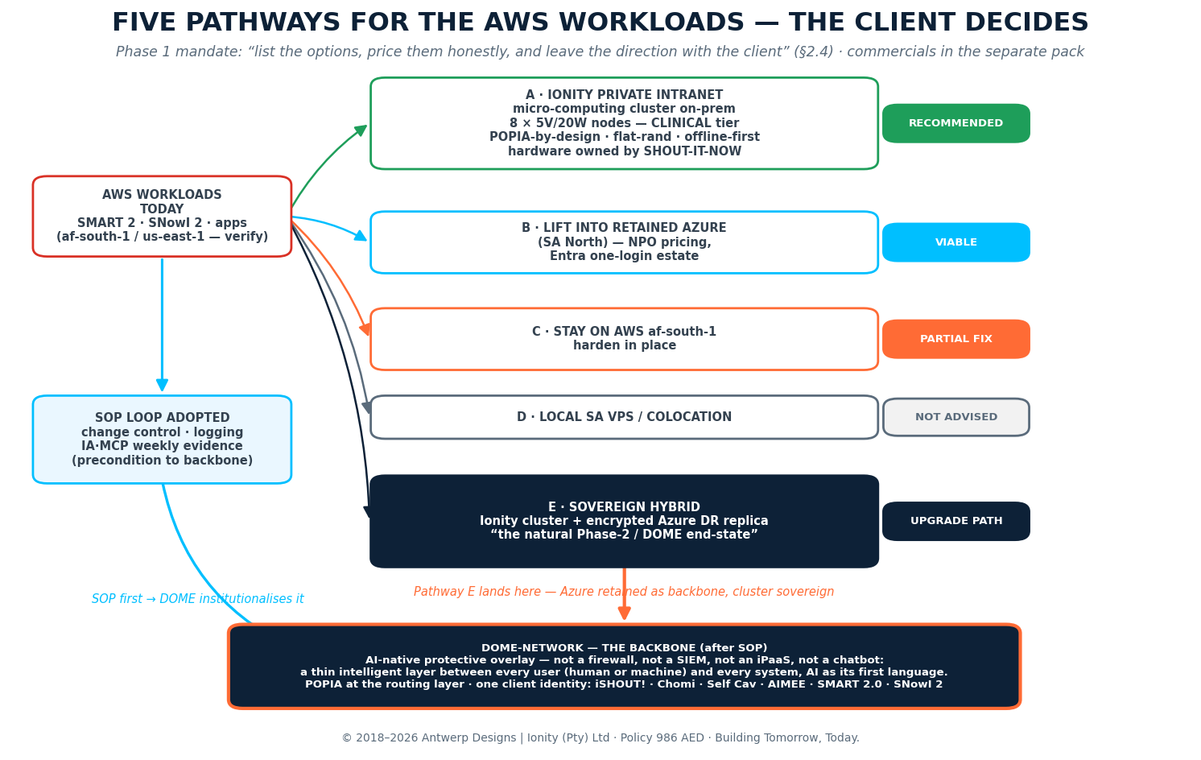
Path | Description | Verdict | Why / conditions
A | Ionity Private Intranet — on-prem micro-computing cluster: eight 5V/20W-class nodes ("draws less than a kettle"), CLINICAL-tier topology; hardware owned by SHOUT-IT-NOW | RECOMMENDED | POPIA-by-design; flat-rand cost; offline-first sync; sovereignty; AI-M edge-AI upgrade line (Q2-2026)
B | Lift AWS workloads into retained Azure (SA North), NPO pricing, Entra one-login | VIABLE | Fastest de-risk of the September cliff; keeps single-tenancy story
C | Stay on AWS af-south-1 and harden in place | PARTIAL FIX | Cost cliff remains; residency verified but sprawl and lock-in stay
D | Local SA VPS / colocation | NOT ADVISED | Trades one dependency for a weaker one; no governance gain
E | SOVEREIGN HYBRID — Ionity cluster + encrypted Azure DR replica | UPGRADE PATH | "The natural Phase-2 / DOME end-state" — A’s sovereignty with Azure resilience; the backbone configuration

How to read this with Section 6: Paths A and B are both honest destinations for the workloads. Path E is where they converge once the SOP is embedded: the cluster carries sovereign clinical workloads, Azure carries DR and the M365/Fabric estate, and DOME-Network becomes the intelligent backbone that routes, protects and audits everything between them.

6. DOME-Network — The Backbone Path
“Not a firewall, not a SIEM, not an iPaaS, not a chatbot — a thin, intelligent layer between the user (human or machine) and the systems, speaking AI as its first language.” — ION-QUO-SHOUT-2026-001, Forward Look
DOME-Network is Phase 2 — and if Exco selects it, it is the backbone of the estate after the SOP: every request, human or machine, passes through one governed layer. POPIA is enforced at the routing layer rather than per-application, and one client identity is unified across iSHOUT!, Chomi, Self Cav, AIMEE, SMART 2.0 and SNowI 2 — the six systems confirmed to carry special personal information. The single console replaces "20 000 tabs": the DOME-principle ERP demo of 2 June was received well precisely because it made the whole stack conversational.

6.1 What DOME institutionalises (AEDI capability matrix)
Capability | What it gives SHOUT-IT-NOW
Predictive mindset | Failure-zone detection and anticipation across integrations, not after-the-fact alerts
Real-time logs & notifications | Every routed request evidenced — the SOP’s "log" step becomes automatic
Staff alignment | Role-scoped access through one identity; JML (F-03) enforced at the layer
ISO alerts & checklists | Control drift surfaced against ISO 27001 / CIS v8 baselines continuously
POPIA at the routing layer | Residency, minimisation and special-PI rules applied before data moves
Edge-AI hardware path | AI-M intelligent motherboard (5V/20W, Q2-2026 line) extends DOME to clinics offline-first

SOP → DOME (the alignment Exco should see): the SOP loop in Section 12 is run by people and evidenced weekly by IA·MCP. DOME is the same loop institutionalised in the architecture — intake, assessment, approval, logging and audit executed at the routing layer. SOP first proves the discipline; DOME then makes it structural. That is why Pathway E is labelled the natural end-state, and why choosing DOME is choosing the backbone, not an add-on.
If DOME is chosen: Workstream E graduates from scoping to build; the Fabric lakehouse and NACOSA dashboards remain unchanged underneath; the cluster (Path A hardware) becomes DOME’s sovereign footing; commercials follow the pack.

7. Systems Inventory & Disposition — the 21 Systems
The authoritative inventory is SHOUT-IT-NOW’s System Assessment workbook (April 2026 update; 19–21 systems across versions — the 21-system view is used here). Six systems carry special personal information: SMART 2, SNowI 2, Chomi, MojaMind, iShout and ShoutLink.
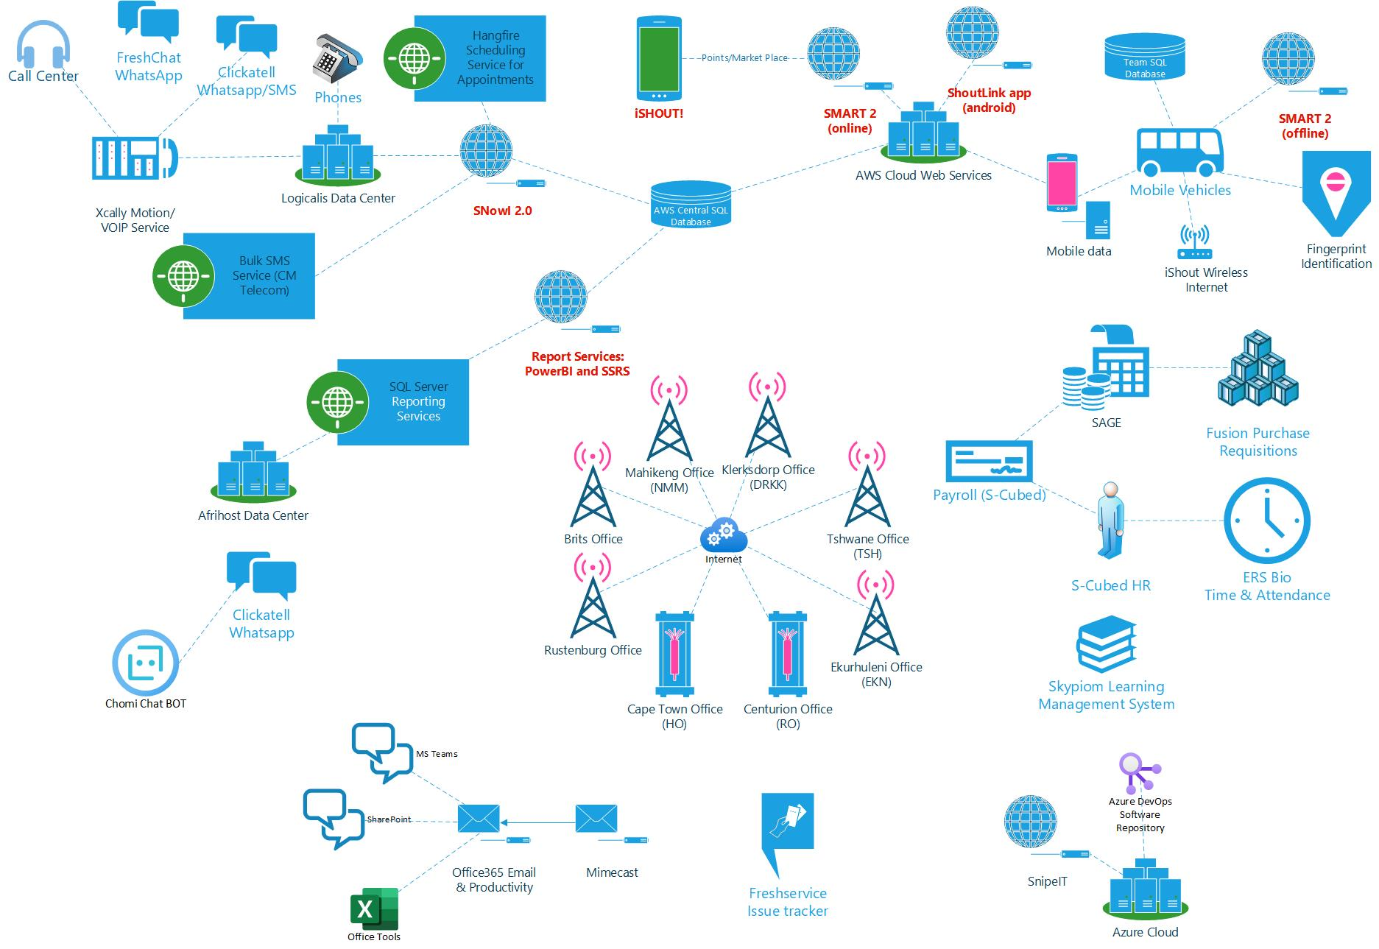
Figure — the estate as recorded: SHOUT-IT-NOW’s own architecture sketch from the IONITY System Assessment pack (Neetin’s workbook set). Every consolidation move below starts from this picture — the audit changed nothing without first recording what is.

7.1 Internal systems (8)
System | Role | Status | Disposition
DataWareHouse | central reporting store | Being disabled | Retire → Fabric lakehouse (Dome path)
Sage Evolution | finance/accounting | Active | Consolidate into single ERP route (F-05)
Fusion (Neurasoft) | finance/operations | Active | Consolidate into ERP route (F-05)
CaseWare | financial reporting | Active | Consolidate or integrate with ERP route
BioSyn Time & Attendance | T&A capture | In development | Keep; API integration to ERP to confirm
S-Cube | payroll & T&A (critical) | Active | Consolidate → Sage X3 People path
SSRS | reporting services | Active | Migrate reporting to Power BI over Gold layer
Salesforce | CRM | Active | Keep; native Fabric connector / mirroring

7.2 External / client-facing systems (13)
System | Role | Status | Disposition
SMART 2 | clinical hub — HIV/STI/TB/PrEP/GBV | Active — special PI | Keep — refresh .NET (F-06); host per chosen pathway; access logging per HPCSA
SNowI 2 | biomedical referrals | Active — special PI | Keep — decouple direct SMART 2 DB read (F-07)
Chomi | GBV chatbot | Active — special PI | Evolve — Option C hybrid (WhatsApp + PWA); re-classify PII under POPIA §26
WhatsApp Platform | client messaging | Active | Keep — real-time Eventstream source
iShout | youth engagement app | Active (DataFree disabled) — special PI | Keep — central support takeover
eLearning Platform | youth learning | Active | Keep — relocate UK-hosted test server
MojaMind | mental-health e-art app (YGLWHIV) | Active — special PI | Protect during migration; Phase 3 cost evaluation
Microsoft 365 | productivity (~250 users) | Active | Keep — foundation of target estate
Azure SnipeIT | asset tracking | Active | Integrate asset register with ERP route
FreshService | ITSM/ticketing | Active | Keep — real-time connector to lakehouse
Mimecast | email security (±40 of ~200 covered) | Active | Exit (F-02) → Azure/Jura; serve ±90-day notice
ShoutLink | legacy link platform — special PI | Under review | Retirement pending; data disposition per POPIA §14
Public web (WordPress) | public site | Active | Remediate residency (F-01); consolidate hosting

7.3 Consolidation matrix — primary target + three market alternatives per system
Direction per Exco steer: every system except BioSyn consolidates onto Azure, Sage X3 and the Ionity Intranet hosting. BioSyn — the biometric hardware layer — stays standalone with an API feed only. Honouring the Phase-1 mandate, each move lists three market alternatives that are deliberately NOT Azure and NOT Sage X3, so the client always sees the honest market picture before committing.
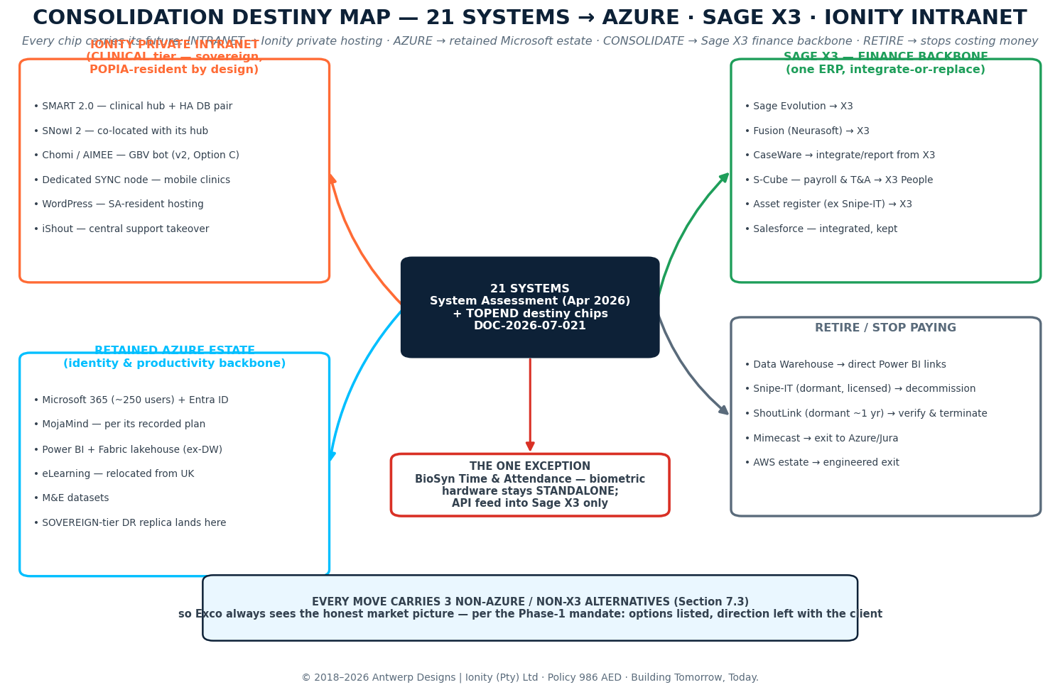
System | Primary target | Alt 1 (non-Azure/X3) | Alt 2 | Alt 3
SMART 2.0 | Ionity Intranet (CLINICAL) + .NET refresh | OpenMRS | Bahmni | DHIS2 Tracker
SNowI 2 | Ionity Intranet — co-located with hub | CommCare | REDCap | KoboToolbox
Chomi / AIMEE | BotPress on hybrid Option C (v2) | Rasa | Turn.io | RapidPro
WhatsApp Platform | Keep (Meta WABA) — Eventstream feed | Twilio | 360dialog | Infobip
iShout | Ionity Intranet — central takeover | Flutter rebuild | Progressive Web App | Glide/AppSheet
eLearning | Azure — relocated from UK | Moodle Cloud | TalentLMS | LearnDash
MojaMind | Azure — per its recorded plan | Keep af-south-1 (interim) | Ionity Intranet | Store-published PWA
Microsoft 365 | Retained Azure backbone | Google Workspace | Zoho Workplace | Nextcloud
Snipe-IT (dormant) | RETIRE — register into Sage X3 | Self-host Snipe-IT on cluster | GLPI | AssetTiger
FreshService | Keep — lakehouse connector | Jira Service Mgmt | Zoho Desk | GLPI
Mimecast | EXIT — Azure Defender / Jura | Proofpoint | Barracuda | Mailcow + rspamd
ShoutLink (dormant) | RETIRE — verify, evidence, terminate | Archive to lakehouse | Static export | —
Public web (WordPress) | Ionity Intranet — SA-resident | Azure App Service* | Afrihost (SA) | Static site (Hugo)
Sage Evolution | Sage X3 | Dynamics 365 BC | Odoo | Xero
Fusion (Neurasoft) | Sage X3 | Odoo | ERPNext | Zoho Books
CaseWare | Integrate / report from Sage X3 | Draftworx | Workiva | Caseware Cloud (keep)
S-Cube (payroll & T&A) | Sage X3 People path | PaySpace | SimplePay | PayDay
SSRS | Power BI over Gold layer | Grafana | Metabase | Apache Superset
Salesforce | Keep — integrated via mirroring | HubSpot | Zoho CRM | Odoo CRM
DataWareHouse | RETIRE → Fabric lakehouse | Direct Power BI source links | PostgreSQL DW on cluster | ClickHouse
BioSyn T&A | STANDALONE — API feed to X3 only | (stays as-is by design) | — | —

* Azure App Service listed for WordPress only as the retained-estate fallback where SA residency is verified. Alternatives are directional candidates for due diligence, not endorsements; selection follows SOP-01 and the vendor checklist in the AI Governance Pack where AI-enabled.

8. Audit Outcome — Findings Register & IA·MCP Baseline
The full register runs F-01→F-27 in the TOPEND final presentation (its own numbering); the Final Report SPINE consolidates the estate picture into the nine headline findings below (SPINE v0.2 numbering, used throughout this IR). The forensic baseline scored 33.7 and 49.1 — Grade F ("Initial") — against CIS v8, ISO 27001, SOC 2, NIST 800-53 and POPIA. The register is the backbone of Workstream B and of every weekly IA·MCP re-score; the cross-walk between numbering schemes sits in the audit pack.
ID | Finding | Rating | Priority | Owner
F-01 | Cloud/POPIA — special PI processed outside SA (SMART 2.0 / SNowI 2 AWS region; af-south-1 vs us-east-1 to be confirmed on record) | RED | P1 | Ionity + Neetin
F-02 | Email security — Mimecast covers ±40 of ~200 mailboxes; phishing exposure | HIGH | P1 | Neetin + Lillian
F-03 | Identity — HR→IT joiner/mover/leaver gap; ±1 000 accounts vs ±260 active people | YELLOW | P2 | Neetin + HR
F-04 | Cost/licence — AWS commitment expiring Sep-26; ±R9k → R60–70k/month | YELLOW | P2 (gates baseline) | Neetin + Ionity
F-05 | Finance — fragmented finance stack (5 parallel systems) | YELLOW | P2 | Pierre + Angela
F-06 | Patch/change — SMART 2.0 on end-of-life .NET runtime, no maintenance cadence | RED (L×S 16) | P1 | Ionity
F-07 | Integrations — Symmetric DS offline sync fragile, unsupported (SMART 2 ↔ SNowI 2) | 12 | P2 | Ionity
F-08 | Vendor custody — single-vendor code & knowledge custody, active loss | 12 | P2 | Ionity + Neetin
F-09 | Data integrity — duplicate client records on special PI | 12 | P2 | Ionity + Neetin

8.1 Cloud forensics highlights (TOPEND numbering) — the quick-win week
TOPEND ID | Finding | Immediate action (§7.1 quick wins)
F-23 | No multi-region CloudTrail / Config / GuardDuty — no record of API activity (RED · P1) | Enable multi-region CloudTrail + Config + GuardDuty
F-24 | Root access key in use — no MFA, keys unrotated (RED · P1) | Retire the root key; enforce MFA (0/6 on AWS today)
F-25 | Security groups open to 0.0.0.0/0 on sync & enrolment tiers (RED · P1) | Close the groups to known ranges
F-26 | S3 bucket "shoutitnow-hosted-content" publicly accessible (AMBER · P2) | Fix bucket policy; verify contents
F-27 | Clinical RDS Single-AZ — no failover | HA DB pair designed into the Ionity cluster
F-01 (TOPEND) | Mobile-clinic SYNC layer maintained reactively by two people, no SLA — the artery of the estate | Dedicated, monitored SYNC node with health-checks (cluster design)
F-02 (TOPEND) | Supplier concentration — clinical core on one external developer; knowledge loss active | Code custody consolidation; escrow; central takeover

8.2 Gains ledger — every line traceable to a finding
Gain | Action (source findings) | Annual effect
G-1 | Exit AWS → Ionity Private Intranet, CLINICAL tier — all AWS workloads (F-06 · F-07 · F-23–F-27) | + R117 600 recurring; removes an AWS cliff exposure of up to R630 000/yr from Sep 2026
G-2 | Decommission dormant Snipe-IT; asset register into the finance backbone (F-11) | + R72 000 — licensed, recorded "Active", not used
G-3 | Retire the Data Warehouse; direct Power BI source links (F-12) | + R60 000
G-4 | Finance consolidation onto the single ERP route (F-05) | Per commercial pack
— | Target estate run-rate after the moves (TOPEND forecast) | ± R285 000–320 000 / yr, rand-denominated

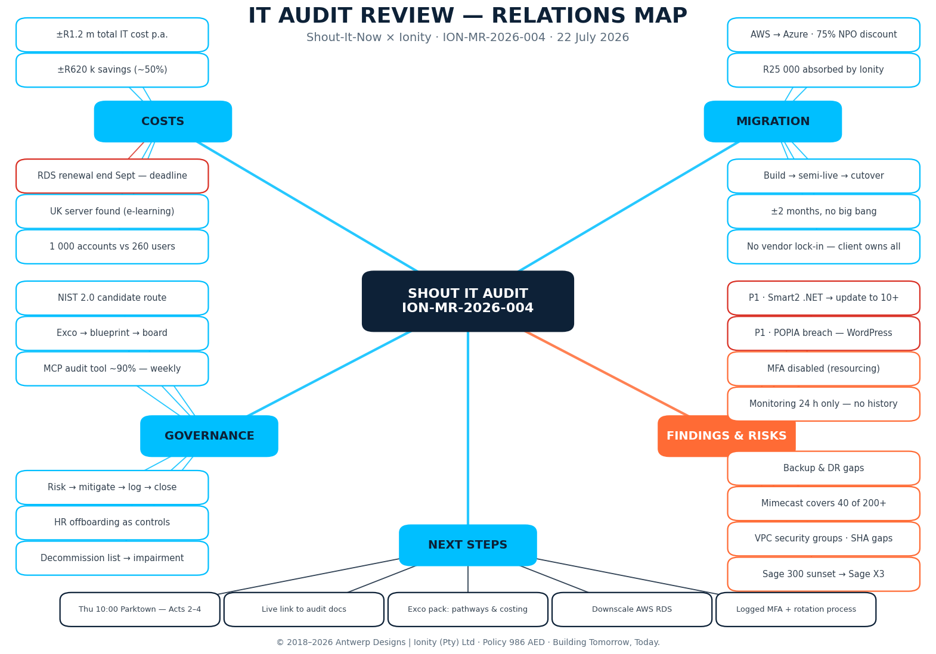

9. Target Architecture
The layered view below shows the Azure-retained backbone common to Pathways B and E — Entra identity, M365, the Fabric lakehouse replacing the DataWareHouse, and the decision layer delivering NACOSA-first dashboards with the grounded agent ("Thabo"). Under Pathway A/E the sovereign cluster carries the clinical workloads with offline-first sync, and DOME-Network wraps the whole estate as the routing backbone (Section 6). Exits: AWS, Mimecast, ShoutLink, parallel finance stack.
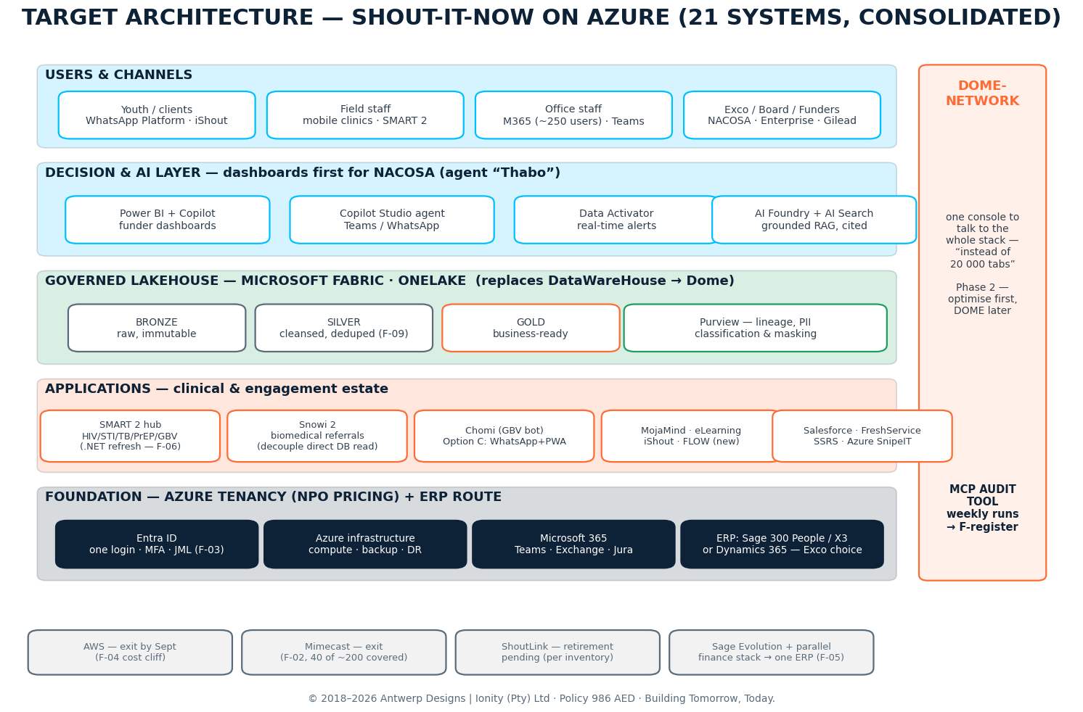
Design principles: build on the existing Microsoft estate; real-time by default; grounded-not-generative AI with cited answers; governed from day one (Purview lineage, PII masking before embedding); phased and reversible; sovereignty by design where special PI lives. Data sourcing is the known bottleneck — source-owner access provisioned in D1 (Vui sessions).

9.1 Hosting — the Ionity solution (where the apps live)
The clinical core leaves the hyperscaler and lands on the Ionity Private Intranet: sovereign micro-computing nodes on SHOUT-IT-NOW’s own floor. Every node is a discrete micro-computer — a failure replaces a part, not a platform. The estate gets what it actually needs: sovereignty, a patch cadence, and a predictable rand-denominated bill. Own the compute, contract the care.
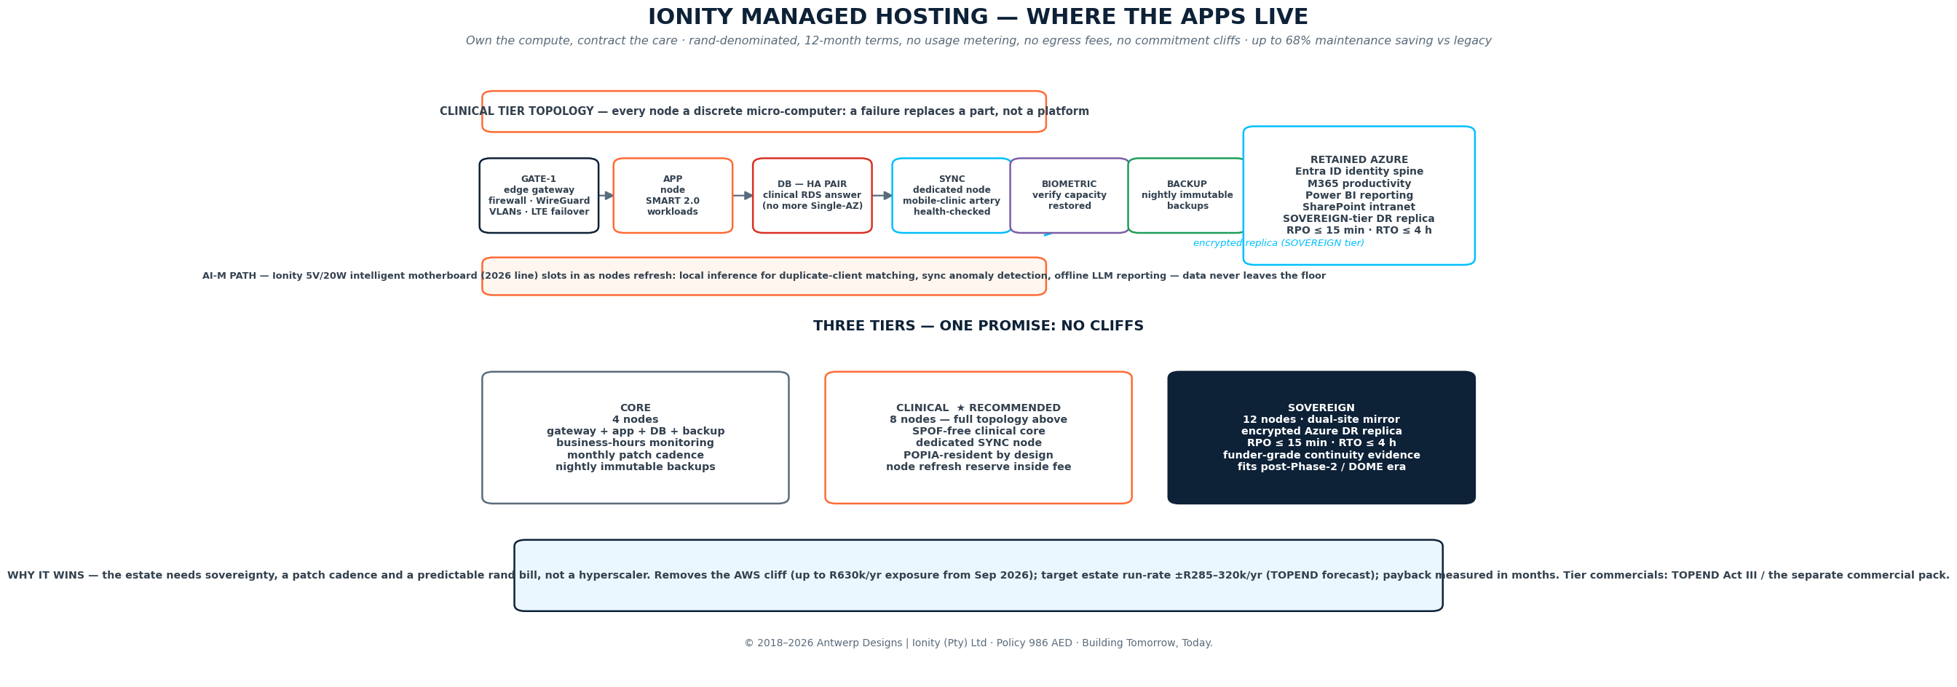
Tier | Nodes | Service level
CORE | 4 | Gateway + app + DB + backup · business-hours monitoring · monthly patch cadence · nightly immutable backups
CLINICAL ★ | 8 | Full topology: GATE-1 edge gateway (firewall, WireGuard, VLANs, LTE failover) · app node · HA DB pair (answers the Single-AZ finding) · dedicated monitored SYNC node · biometric verify capacity restored · refresh reserve inside the managed fee
SOVEREIGN | 12 · dual-site | Everything in CLINICAL mirrored across two premises · encrypted DR replica into retained Azure · RPO ≤ 15 min, RTO ≤ 4 h evidenced for funders · fits the post-Phase-2 / DOME era

Terms that matter: rand-denominated, 12-month terms, no usage metering, no egress fees, no commitment cliffs; up to 68% maintenance saving vs legacy support models; node-by-node refresh from year 4 within the managed fee; AI-M intelligent motherboards (5V/20W True-Edge-AI, 2026 line) adopt as they ship — local inference for duplicate-client matching (F-09), sync anomaly detection, even an offline LLM assistant, all without data leaving the floor. Tier commercials: TOPEND Act III / the separate commercial pack.

9.2 What lands where
Ionity Intranet (CLINICAL): SMART 2.0 + HA DB pair · SNowI 2 co-located · Chomi/AIMEE (v2, Option C) · dedicated SYNC node for mobile clinics · WordPress SA-resident · iShout under central support.
Retained Azure: Entra ID identity spine · M365 productivity (~250 users) · Power BI + Fabric lakehouse · SharePoint intranet · MojaMind (per its own recorded plan, Stellenbosch governance preserved) · M&E datasets · asset register into the finance system · SOVEREIGN-tier DR replica.

10. Implementation Timeline & Workstreams
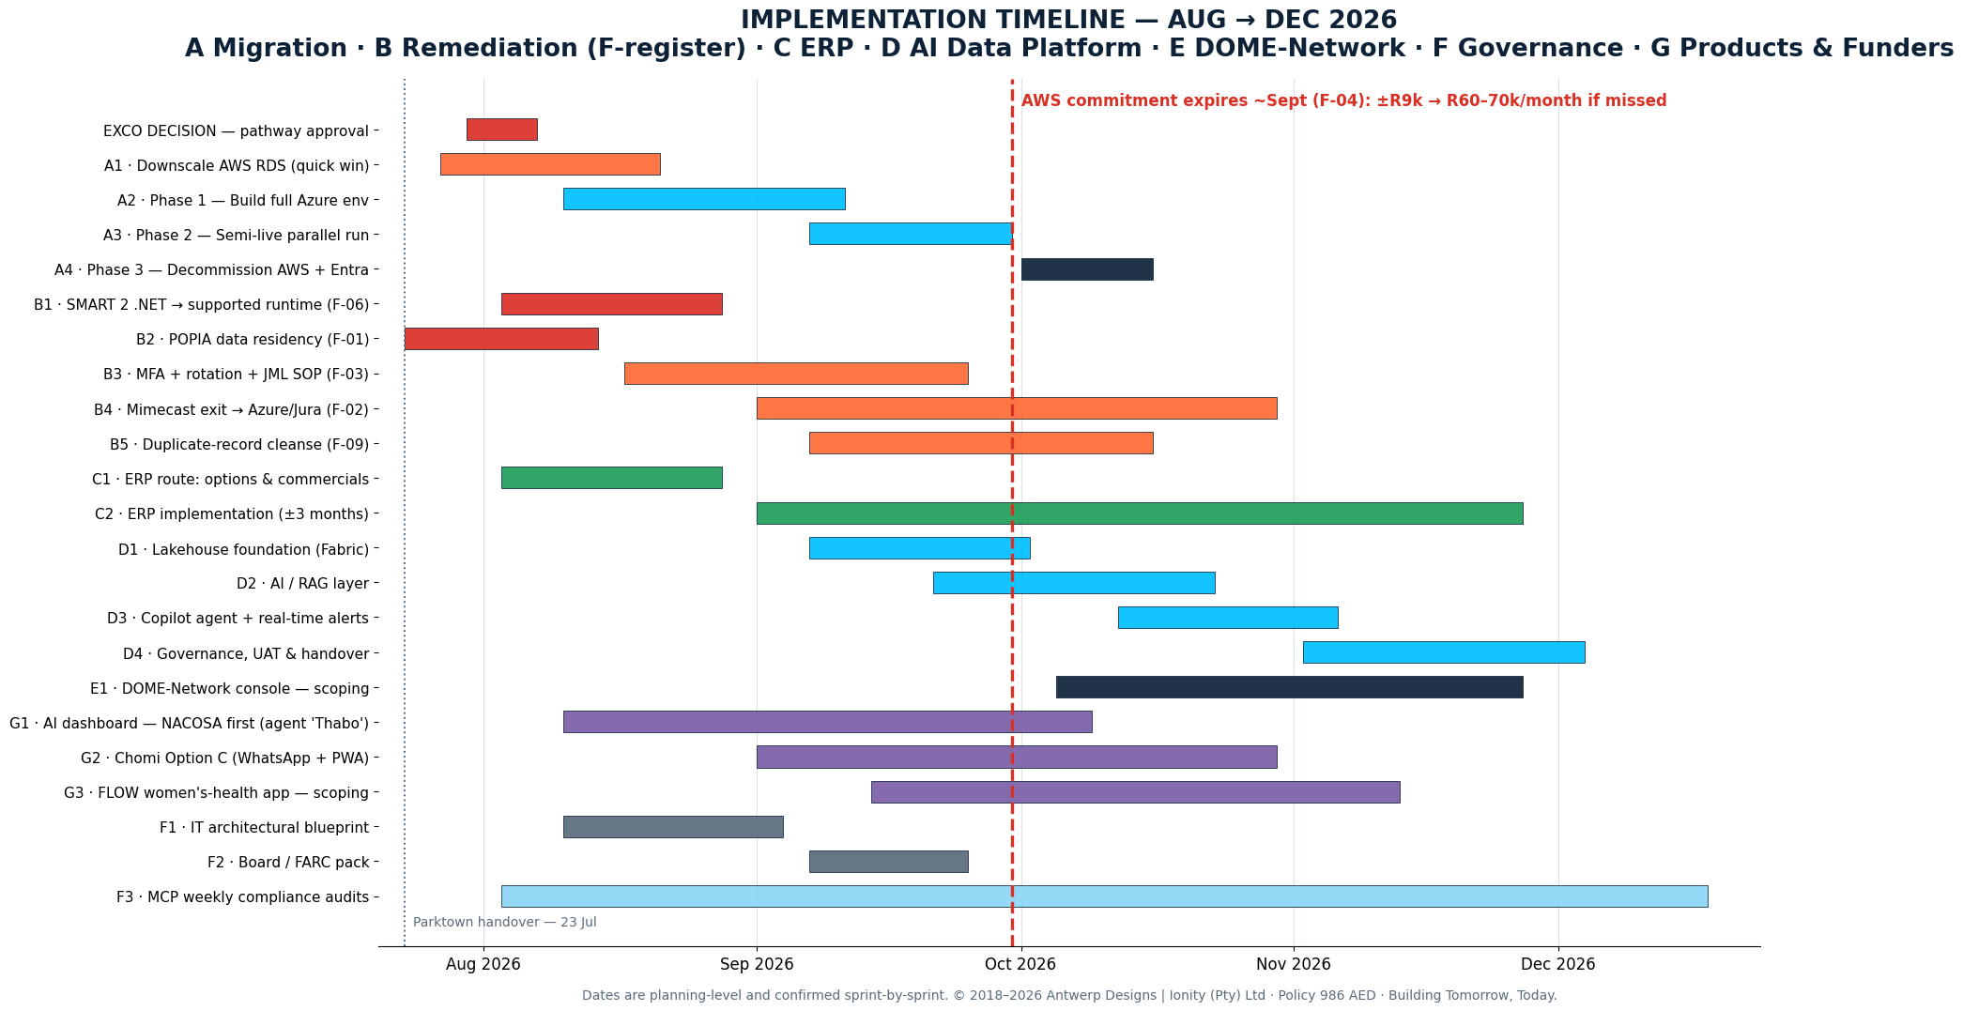
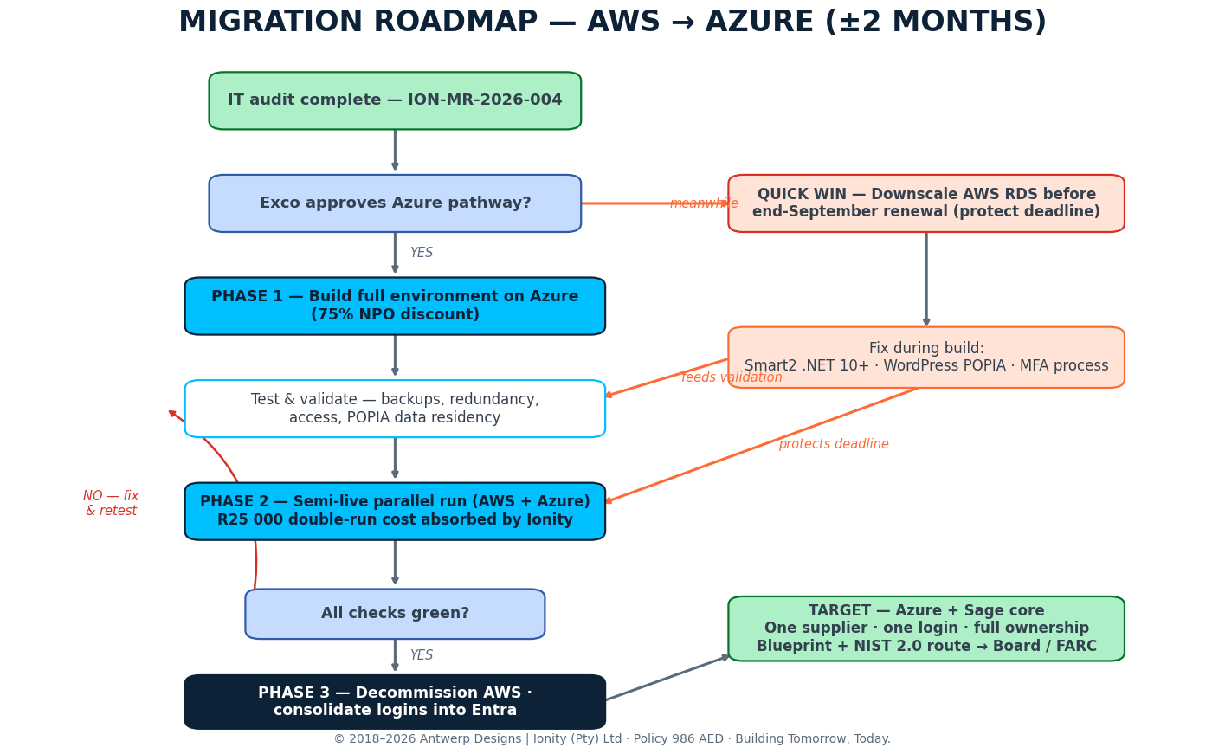
WS | Scope | Window | Exit criterion
A | Engineered AWS exit per chosen pathway (A/B/E): RDS quick win, build, semi-live, decommission + Entra | 27 Jul – 16 Oct | AWS bill R0; one login
B | Remediation of F-register: F-06 .NET, F-01 residency, F-03 JML, F-02 Mimecast, F-09 dedupe | 23 Jul – 30 Oct | P1s closed & logged
C | ERP route: options & commercials, then ±3-month implementation | 3 Aug – 27 Nov | Single ERP live; F-05 closed
D | AI Data Platform: lakehouse → RAG → agent & alerts → UAT (12–14 weeks) | 7 Sep – 4 Dec | UAT sign-off; NACOSA dashboard live
E | DOME-Network backbone: scoping → (on selection) build on cluster + Azure DR | 5 Oct – 27 Nov (scope) | Scoped, sized; build gate passed
F | Governance: blueprint, Board/FARC pack, IA·MCP weekly audits | 3 Aug – ongoing | Board approval; 4 green audits
G | Products & funders: NACOSA dashboard; Chomi Option C; FLOW app (SNPR002P10626IO) | 10 Aug – 13 Nov | Funder demo; scoped backlogs

11. Workstream Detail & RACI
Activity | Ionity (Johan + team) | Neetin (IT Ops) | Lillian (Commercial/Gov) | Pierre / Angela (Finance) | CEO / 3rd parties
Exco decision pack & pathway choice | R | C | A | C | Dr Mtshali — final approval
AWS exit build & cutover (path A/B/E) | R | C | I | I | Microsoft / AWS — C
AWS RDS downscale (F-04) | C | R | I | I | AWS — C
SMART 2 .NET refresh (F-06) / residency (F-01) | R | C | I | I | Garrett (Smart2) — C
MFA + rotation + JML SOP (F-03) | C | R | I | C (HR) | —
Mimecast notice & Jura consolidation (F-02) | C | C | R/A | I | Mimecast — I
ERP route & implementation (F-05) | C | C | A | R | Sage / Preferred Solutions / MS — R
AI Data Platform + NACOSA dashboard | R | C | I | I | Vui (data) — C
Chomi Option C / FLOW scoping | R | C | A (FLOW: Paul) | I | Botpress — I
DOME-Network scoping & build gate | R | C | A | I | Dr Mtshali — I
AI Governance Pack rollout (Section 14) | C | R (author) | Gov review | I | Daniel Botha (legal) — C
IA·MCP weekly audit review | C | R | I | I | —

12. SOP — Standard Operating Procedures
Every change runs through one loop — run by people now, institutionalised by DOME later (Section 6). The audit’s core lesson stands: mitigations existed but were not documented. From now: if it is not logged, it did not happen.
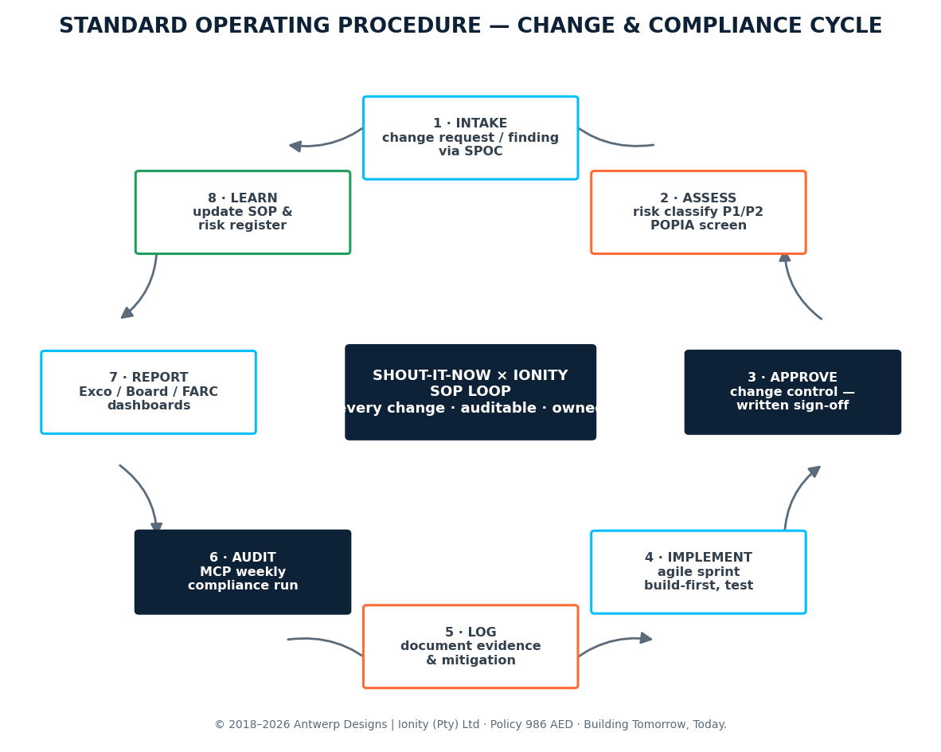

12.1 SOP register
SOP | Purpose | Owner | Cadence | Evidence
SOP-01 | Change management — intake via SPOC, written approval, rollback stated | Ionity + Neetin | Per change | Change record + sign-off
SOP-02 | Access & identity — MFA enforced, 90-day rotation, usage reporting | Neetin | 90 days | Entra reports
SOP-03 | Joiner–mover–leaver — checklist, revocation, data removal (F-03) | HR + Neetin | Per event | JML checklist, logged
SOP-04 | Backup & disaster recovery — schedule, restore tests, SPOF watch | Ionity | Monthly test | Restore test log
SOP-05 | Security awareness — phishing training, tracked by system | Neetin | Quarterly | Training log per staff
SOP-06 | Weekly IA·MCP compliance audit — run, review, flag, assign | Neetin (review) | Weekly | IA·MCP report archive
SOP-07 | Vendor & procurement — integrate-or-replace rule; contract/notice register | Angela | Per vendor | Vendor register
SOP-08 | Data protection & POPIA — residency checks, special-PI handling, breach response | Ionity + Neetin | Continuous | Purview + register
SOP-09 | AI use & tooling — per the AI Governance Pack (Parts A–J): approval, risk tiering, incident response | Neetin + Gov | Per use-case | Tool register + declarations

12.2 Worked procedure — change management (SOP-01)
1. Intake: changes enter via the SPOCs (SHOUT-IT-NOW: Neetin Daya; Ionity: Johan van Antwerp). No side-channel work.
2. Assess: classify against the F-register and AI risk tiers; screen POPIA/special-PI impact; scope/fee/timeline changes become written change requests.
3. Approve: written sign-off by both parties before work — per the quotation change-control clause.
4. Implement: agile sprint; build-first with rollback; live programmes (MojaMind) protected.
5. Log: record what, who, when, why, evidence of mitigation.
6. Audit: weekly IA·MCP run re-scores the estate against the register, frameworks and POPIA lens.
7. Report: exceptions to Exco monthly; posture pack to Board/FARC per cycle (King IV accountability).
8. Learn: update SOPs and the F-register; recurring exceptions become roadmap items — and, under DOME, routing rules.

13. IA·MCP v1.7.0 — Forensic Audit Engine
Ionity’s IA·MCP forensic engine (v1.7.0, ~90% productised at the audit review) ran the Phase-1 scans and is provided as an included service at no subscription cost; only incremental version updates driven by changing compliance requirements may be charged. It exists so SHOUT-IT-NOW can audit itself — with or without Ionity.
Capabilities: 20 forensic tools; connects to AWS and Azure with read-only keys and pulls logs, configuration and account data in one run; scores posture against CIS v8, ISO 27001, SOC 2, NIST 800-53 and POPIA (baseline: 33.7 / 49.1 — Grade F "Initial"); maps results to the findings register with POPIA flags; weekly scheduled runs.
Requirements: read-only keys/scopes per environment; named reviewer (Neetin) on the SOP-06 cadence; report archive retained; escalation for red findings; re-baseline after each workstream gate — target is a visible climb out of Grade F, re-scored weekly.
Boundaries: IA·MCP evidences and flags — it does not change systems. Remediation flows through SOP-01 with human approval, consistent with the "no solely automated high-impact decisions" rule in the AI Governance Pack.

14. AI Governance & Compliance Alignment
SHOUT-IT-NOW already owns the policy backbone: the AI Governance Pack (2026 S^F1, drafted by Neetin Daya with Ionity regulatory context; legal review Daniel Botha; governance review Lilian Monji; final approval Dr Ntombifikile Mtshali, CEO). This IR adopts it wholesale as SOP-09 and aligns every AI element — Chomi, the "Thabo" agent, Self Cav/AIMEE, copilots, workflow automations and DOME itself — to its structure.
Pack element | Roadmap alignment
Part A — AI Governance Policy | Adopted as policy layer above SOP-09; review cycle mirrors board reporting
Part B — Acceptable Use Standard | Five core user rules + prompt hygiene → staff training (SOP-05)
Part C — Tool & Use-Case Approval | Every new AI tool/agent (incl. Thabo, Chomi v2) passes intake before build
Part D — Risk Classification Matrix | Four tiers (Low / Medium / High-Impact / Prohibited) applied at SOP-01 assessment
Part E — High-Impact Control Standard | No solely automated high-impact decisions — human-in-the-loop everywhere, incl. IA·MCP and DOME routing
Part F — Data Protection & Survivor-Safety | De-identification and survivor-safety standard bind Chomi/GBV flows; prompt retention rules
Part G — Incident Response | AI incidents join the SOP loop and the breach procedure (SOP-08)
Parts H–J + Annexures | Vendor checklist for AI suppliers; tool register; user declarations — feed SOP-07 register

14.1 Compliance interview threads (QTE-2026-002)
Thread | Legal basis | Roadmap hook
01 Information Officer registration (6 Qs) | PAIA | Confirm registration; governance pack Part I
02 Conditions for lawful processing (10 Qs) | POPIA §§8–25 | Purview classification; SOP-08
03 Cross-border data transfer (6 Qs) | POPIA §72 | F-01 — confirm af-south-1 vs us-east-1 on record; pathway choice
04 Clinical records (≈8 Qs) | HPCSA Booklets 10 & 14; NHA §13; ECTA | SMART 2 access logging (user, timestamp, action)
05 Donor & funder reporting (≈8 Qs) | PEPFAR SIMS/COP; Global Fund OIG; USAID ADS 508 | NACOSA-first dashboards; auditable lineage
06 Special personal information (≈8 Qs) | POPIA §§26–35; Children’s Act 38/2005; DV Act | Six special-PI systems governed; Chomi re-classification

Regulatory horizon: the pack also anchors the AU Continental AI Strategy (2024; implementation 2025–2030), the SA National AI Policy Framework (DCDT 2024), UNESCO AI Ethics and OECD AI Principles — with NIST AI RMF 1.0 and ISO/IEC 42001:2023 as the management-system frame for Chomi, Self Cav and AIMEE. DOME-Network is the architectural expression of this pack: the routing layer is where policy stops being paper.

15. Cost Baseline & Commercial Note (Indicative)
ALL FORWARD-LOOKING INVESTMENT FIGURES ARE EXCLUDED BY DESIGN. The formal Ionity commercial pack — pathways A–E (incl. the DOME cost models in the audit repository), remediation, ERP, AI Data Platform — is issued separately and supersedes any earlier indicative numbers. Nothing here is a quotation.
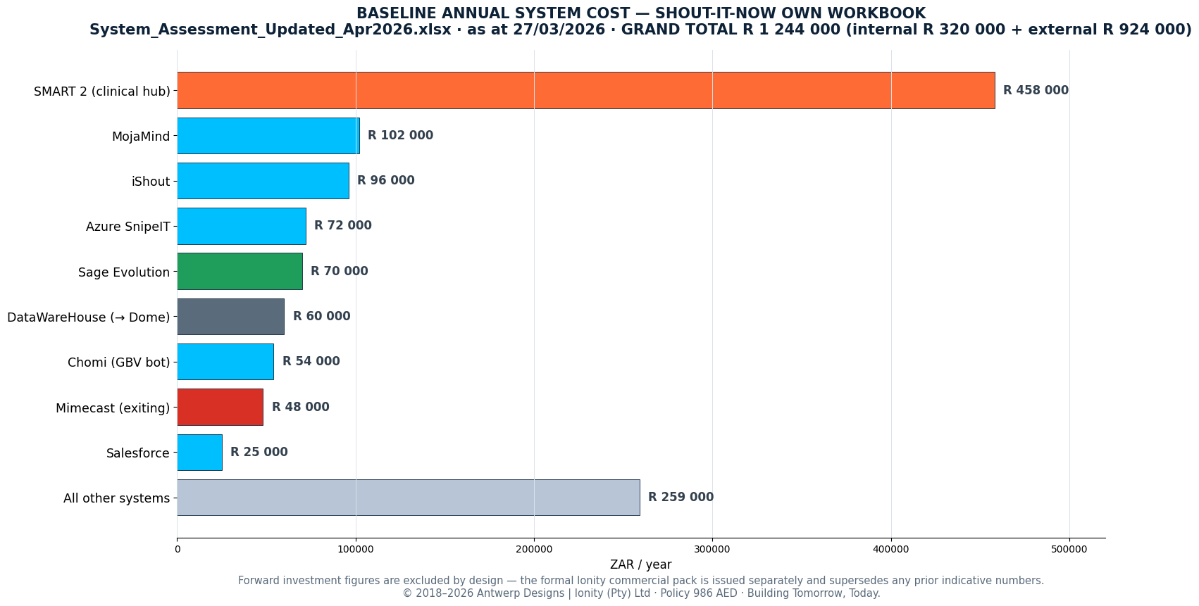
Baseline item | Amount (ZAR/yr) | Source
Internal systems subtotal | R 320 000 | System Assessment workbook (27/03/2026)
External systems subtotal | R 924 000 | System Assessment workbook (27/03/2026)
GRAND TOTAL — current estate | R 1 244 000 | System Assessment workbook (27/03/2026)
Addressable through this roadmap | ±half of total | Audit review, 22 Jul (ION-MR-2026-004)
AWS cliff if unaddressed (F-04) | ±R9k → R60–70k / month | 8-point synthesis; TOPEND
Pathway economics (A–E) | Commercial pack | DOME cost models — audit repository
ERP options (Sage routes vs Dynamics 365) | Commercial pack | Finance meetings; Sage demo 22 Jun

16. Risk & Mitigation
Risk | Rating | Mitigation | Owner
Miss the ~Sept AWS expiry (F-04) | HIGH | A1 downscale now; pathway build closes before deadline; weekly tracking | Neetin + Ionity
Pathway indecision stalls everything | HIGH | Section 5 pack to Exco first week of Aug; decision gate on the Gantt | Lillian / Dr Mtshali
POPIA exposure until F-01 lands | HIGH | B2 immediate; §72 confirmation on record; residency in every gate | Ionity + Neetin
Single-person IT dependency | HIGH | SOPs + IA·MCP automation; Ionity backup under SLA v1.0; documentation-first | Lillian (resourcing)
Vendor custody loss continues (F-08) | MED | Code escrow / repo consolidation; central takeover of iShout support | Ionity + Neetin
Fragile SMART 2 ↔ SNowI 2 sync (F-07) | MED | Decouple via governed layer; offline-first design under Path A/E | Ionity
ERP decision stalls (F-05) | MED | Options + commercials in Aug; integrate-or-replace rule | Pierre + Angela
AI use outpaces governance | MED | SOP-09 intake mandatory; Part D tiering; no solely automated high-impact decisions | Neetin + Gov
Duplicate special-PI records persist (F-09) | MED | Silver-layer dedupe + data-steward review | Ionity + Neetin
Source-owner access delays (dashboards) | MED | Provision in D1; Vui sessions scheduled | Ionity
Scope creep | MED | SOP-01 — written, priced, signed before work | Both SPOCs

17. Governance, Reporting & Decision Path
Decision path: Johan presents this IR with the pathway pack and commercials to Exco; Exco selects the pathway; the IT architectural blueprint is drawn from that decision and taken to the Board and the Finance, Audit & Risk Committee, with final approvals at CEO level (Dr Ntombifikile Mtshali). Control frameworks: NIST CSF 2.0, ISO 27001:2022 and CIS v8 for the estate; NIST AI RMF 1.0 and ISO/IEC 42001:2023 for the AI layer; POPIA throughout; King IV accountability for board reporting.
Reporting cadence: weekly IA·MCP score (SOP-06) → monthly exception summary to Exco → per-cycle posture pack to Board/FARC. Acceptance and the final-payment trigger follow the signed closeout per the Progress Sign-Off Sheet V1.0 and SOW.
Ownership: SHOUT-IT-NOW retains tenancy, hardware (Path A/E), data and code throughout — no lock-in. CONFIDENTIAL under Policy 986 AED; mutual NDA v1.2 and SLA v1.0 on file.

18. Acceptance Criteria & Success Metrics
Criterion | Measure | Target
Pathway selected & gated | Exco minute; blueprint issued | Aug 2026
AWS decommissioned | AWS monthly bill = R 0 | 31 Oct 2026
Identity consolidated (F-03) | Active staff in Entra with MFA; accounts rationalised from ±1 000 | 30 Sep 2026
P1 findings closed (F-01, F-06) | Supported .NET; SA residency verified on record (§72) | 31 Aug 2026
IA·MCP maturity climb | From 33.7 / 49.1 (Grade F) — 4 consecutive green weekly reports | Nov 2026
Backup & DR proven | Documented restore test | 30 Sep 2026, then monthly
Email security consolidated (F-02) | Mimecast exited; ~200 mailboxes covered | On notice expiry
ERP live (F-05) | Single ERP; first parallel payrun reconciled | Nov–Dec 2026
NACOSA dashboard live | Funder-ready, governed, cited answers | Oct 2026
AI governance operational | SOP-09 intake live; tool register populated; declarations signed | Sep 2026
DOME build gate | Scoped, sized, priced; Exco go/no-go | 30 Nov 2026
Savings realised | Addressable share of R1 244 000 baseline captured (per commercial pack) | FY 2027

19. Linked Resources & References
Miro board — audit mindmap, migration roadmap, action tracker
Canva infographic — audit mindmap one-pager
Notion meeting note — IT Audit Review (22 July 2026)
Google Drive — meeting note backup
Ionity Global — www.ionity.today
Source record: SOW; IT Audit Scope Reference v1.0 (10 pillars + 5 foundations); quotations ION-QUO-SHOUT-2026-001 v3/v5 & MULTI and 002; QTE-2026-002 Compliance Interview Questionnaire; AI Governance Pack 2026 S^F1 (Parts A–J + annexures); TOPEND_INDEX V2 (DOC-2026-07-021, 160-file repository); System Assessment workbook (Apr 2026); Final Report SPINE v0.2; A1C Finance & HR Audit; Website Audit SIN-WEB-2026-R01 v1.4; Technical Architecture Report (Jul 2026); Datawarehouse Proposal v3.0 (GCT 2024); project tracker; meeting record ION-MMR-2026-01…21; ION-MR-2026-004 v1.2; Progress Sign-Off Sheet V1.0; Mutual NDA v1.2; SLA v1.0.
Visual pack embedded in this document: relations mindmap; five-pathways map; DOME backbone panel; consolidation destiny map; Ionity hosting topology & tiers; target architecture; implementation Gantt; exit flow; SOP cycle; baseline cost chart; and the client’s own current-state architecture record. Companion visuals: the Canva mindmap infographic (linked above, with three alternate layouts in the Canva account) and the live Miro working board — both part of the handover.

Appendix A — Document Control & Provenance
Field | Value
Document | Implementation Roadmap (IR) — SHOUT-IT-NOW
Reference | ION-IR-2026-001 · Version 4.0 (FINAL) · 22 July 2026 · Engagement Q021-SN01-AD1-26D / QTE-2026-002
Classification | CONFIDENTIAL — Policy 986 AED
Author | Johan Wilhelm van Antwerp — Ionity Global (Pty) Ltd (AEDi)
Team | Ian Raven · Dennis Grobler · Mike Kandolo · Robin du Toit
Contact | ai@ionity.today · www.ionity.today · +27 64 699 9877
Prepared for | SHOUT-IT-NOW — SPOC: Neetin Daya · CEO: Dr Ntombifikile Mtshali
Commercials | Issued separately (incl. DOME cost models); this IR contains none
Rights | © 2018–2026 Antwerp Designs | Ionity (Pty) Ltd · All rights reserved · TM²

Appendix B — Meeting Record Index
Date (2026) | Record | Substance
02 Jun | Client feedback | DOME-principle ERP demo — well received; "optimise first, DOME later" agreed
15 Jun | Kick-off (Phase 1) | Engagement start; sprint plan; info-request list issued
18 Jun | FLOW scoping | Women’s-health Android app; Project NR SNPR002P10626IO; decision-maker Paul
22 Jun | Sage 300 People demo | ESS, payroll/HR, GL; Preferred Solutions to scope; NPO quote requested
24 Jun | Progress / status | Sprint status; progress report & sign-off flow
29 Jun | AI dashboard scoping | NACOSA first, ahead of Enterprise and Gilead; agent "Thabo"; data-sourcing bottleneck; Vui
30 Jun | 8-point synthesis | RDS cliff; Mimecast 40/~200; ~250 M365 users; Chomi Option C (~3 333 participants)
01 Jul | Consolidated report | Full record to date (ION-MMR series)
20 Jul | A1C Finance & HR hand-in + TOPEND final | 50-page final presentation; five pathways tabled; IA·MCP baseline scores
22 Jul | IT Audit Review (Act 1) | ION-MR-2026-004 — findings presented; this IR commissioned
23 Jul | Parktown handover | Acts 2–4 + Act 1 recap; this document is the hand-over pack

